**Day 7**

**Inheritance, Abstraction, Interface, Polymorphism**

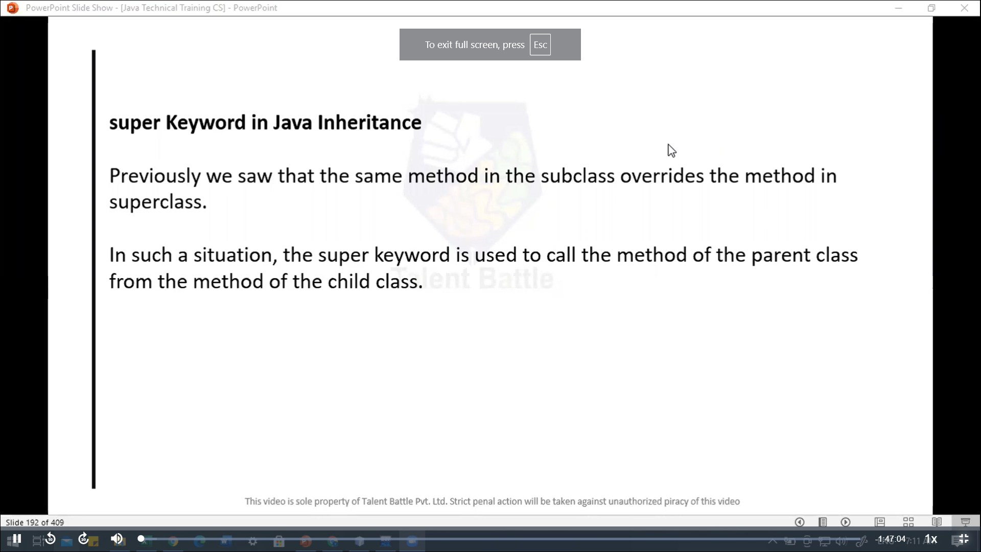

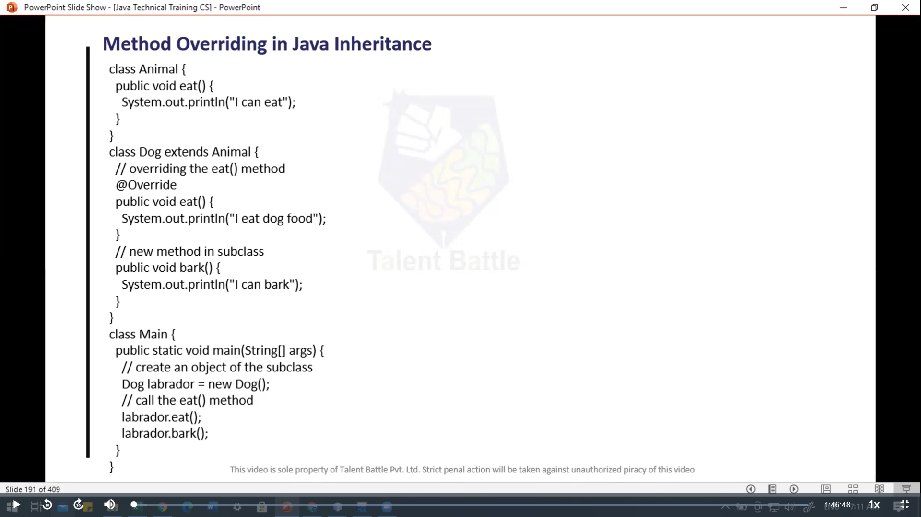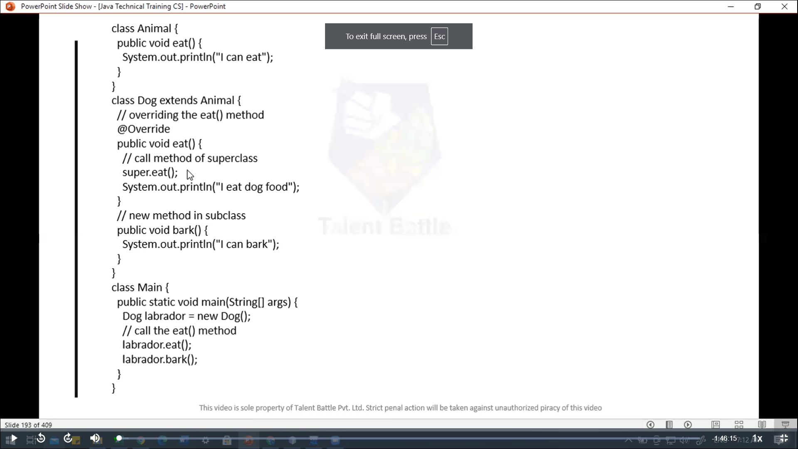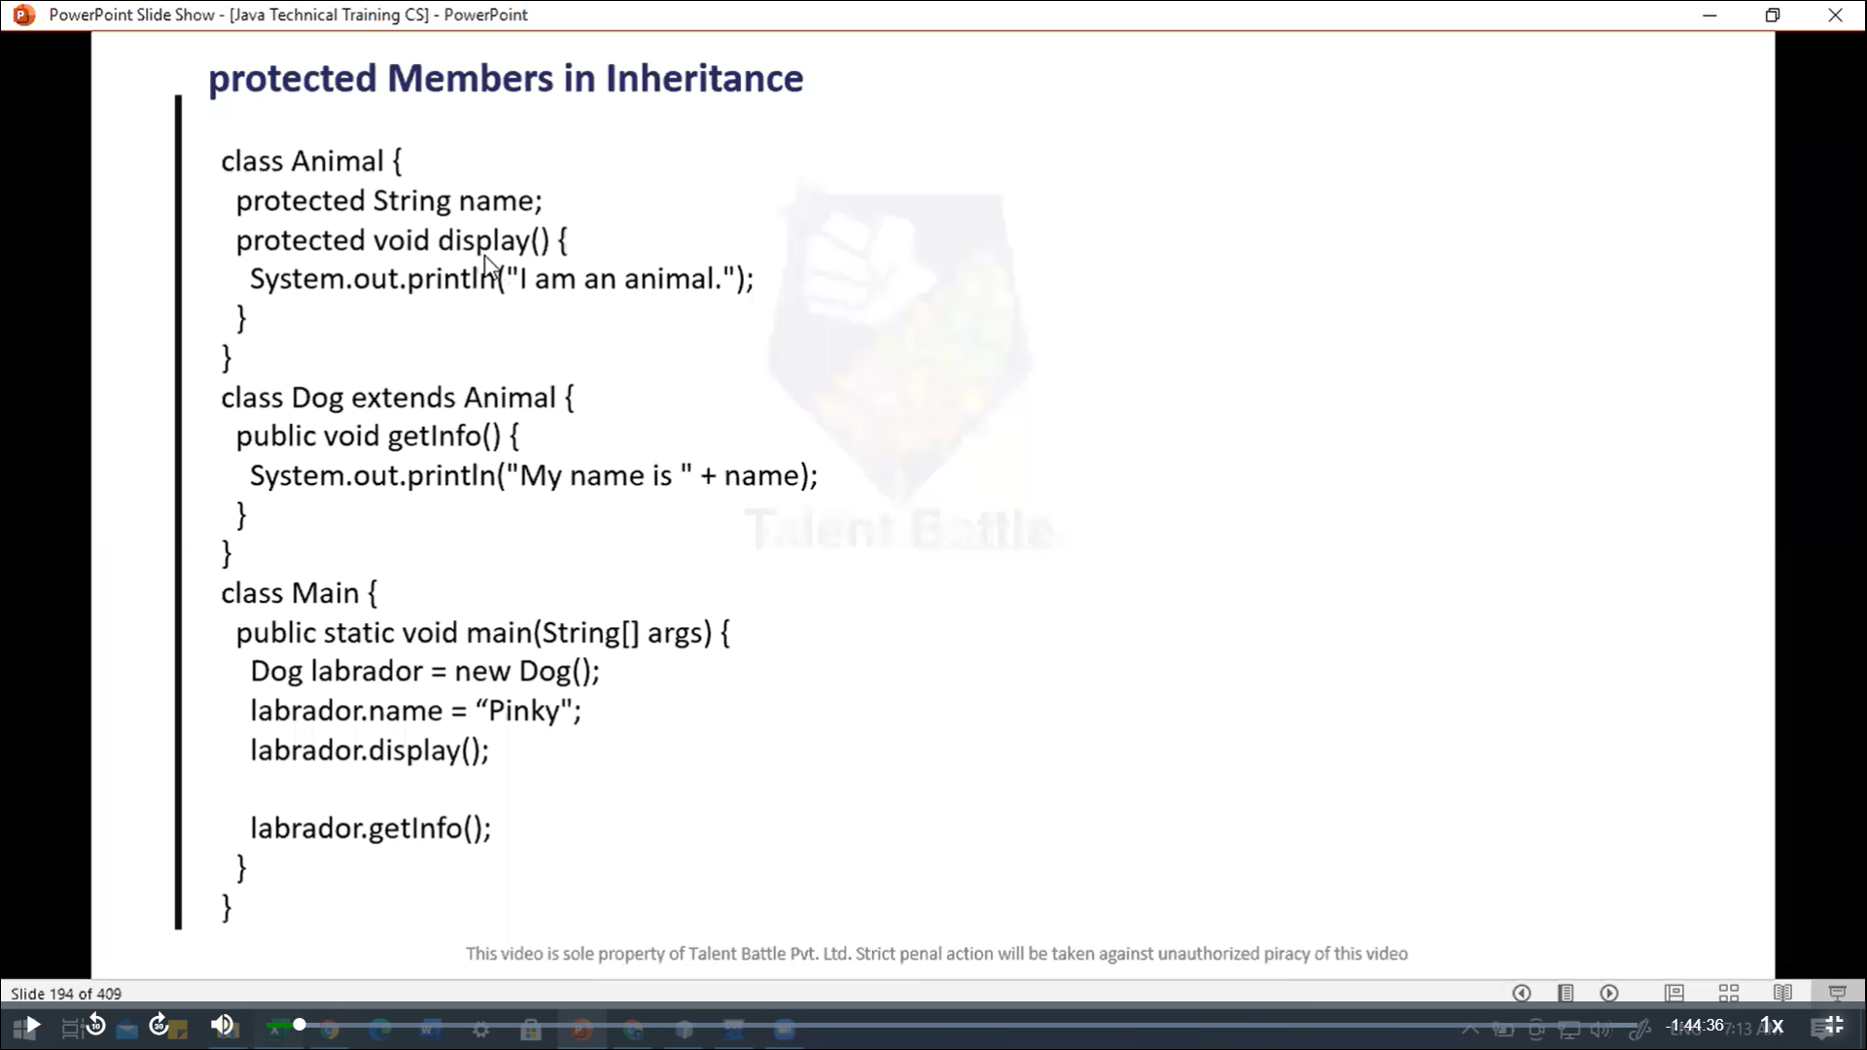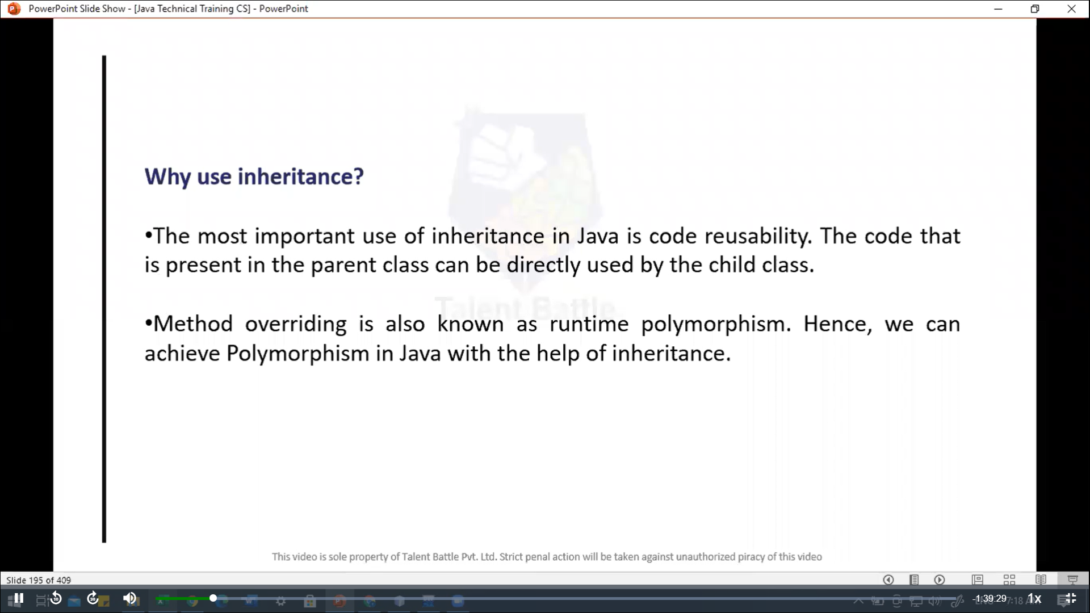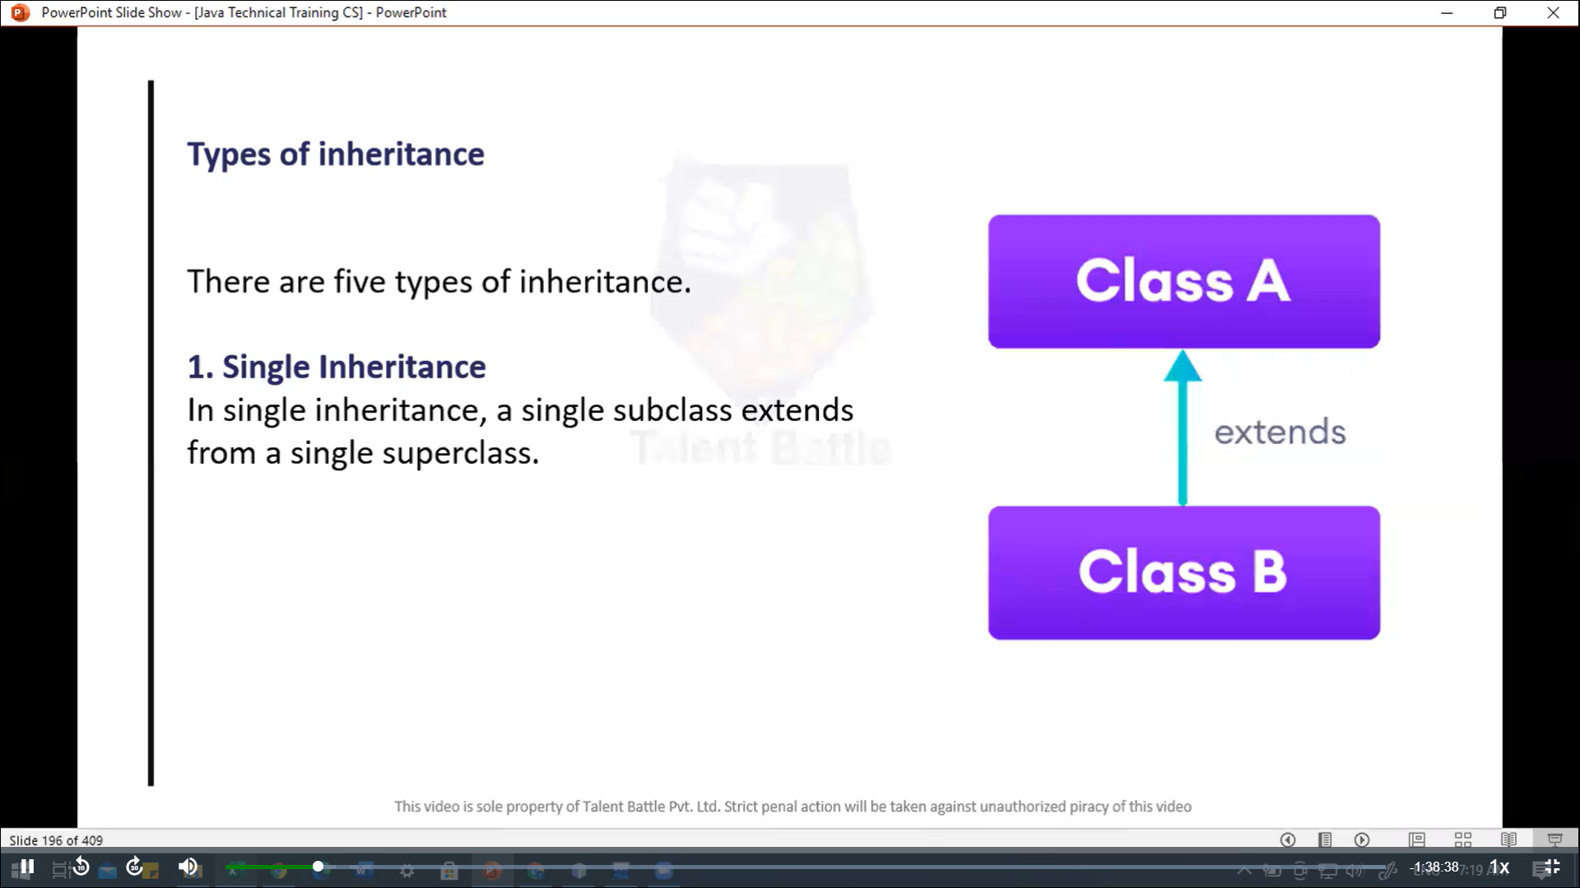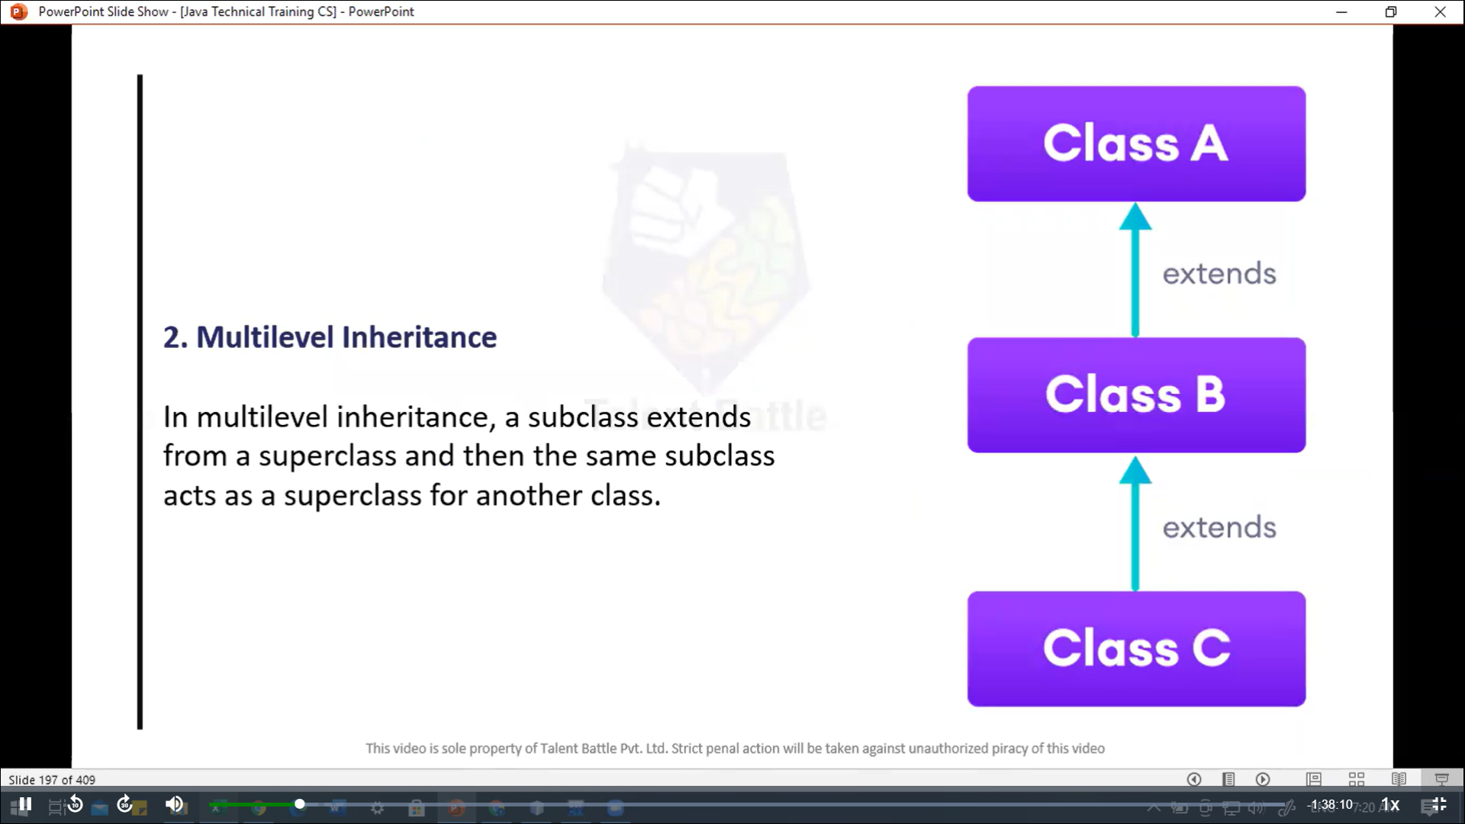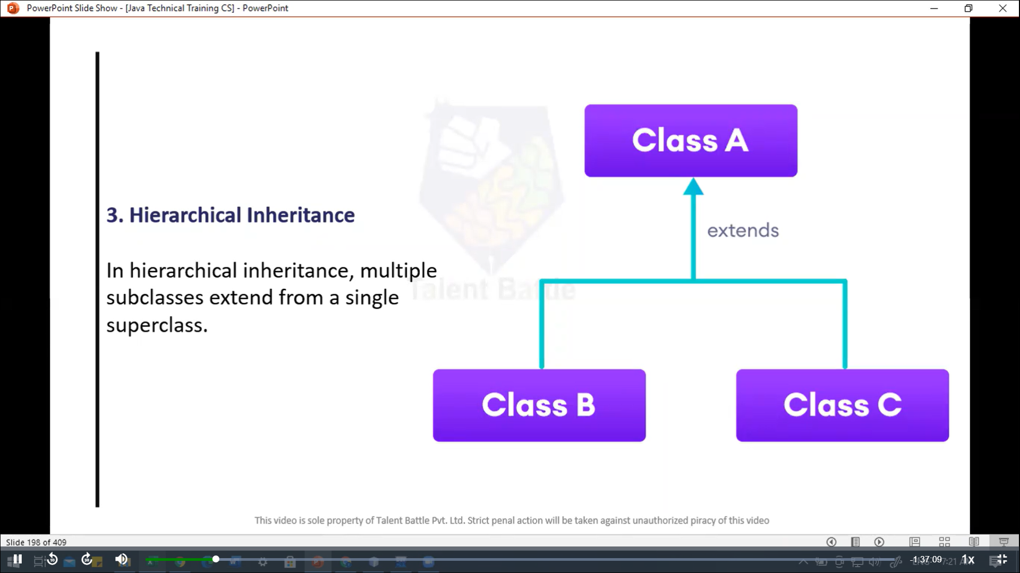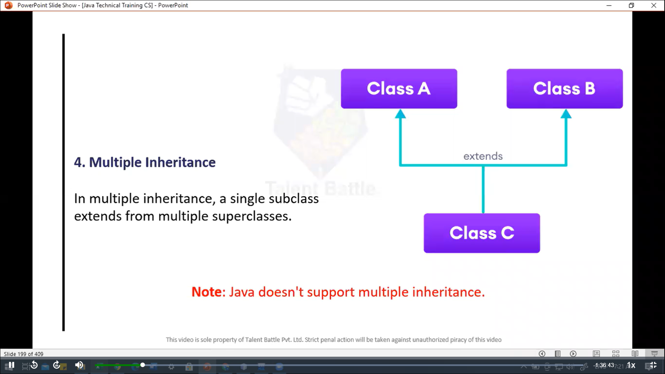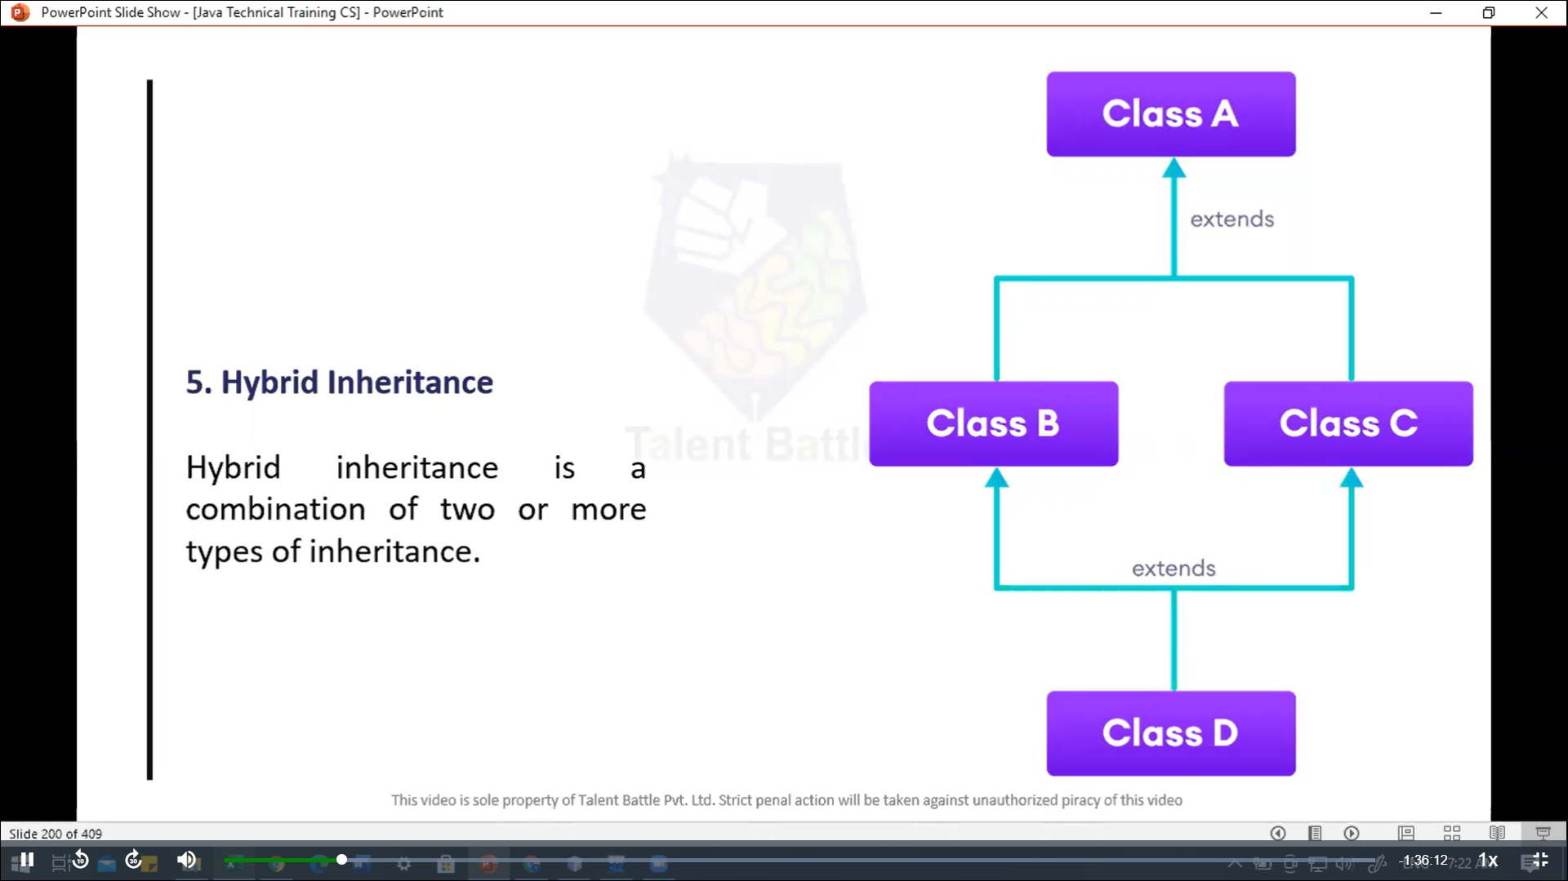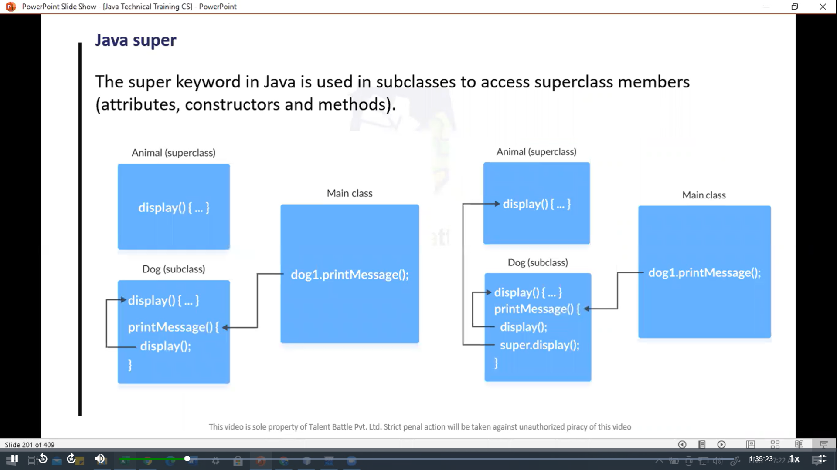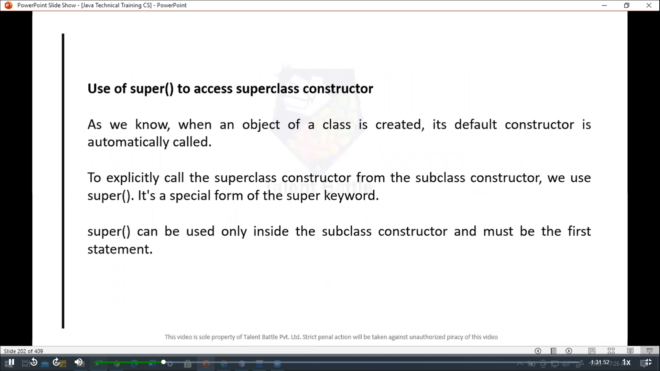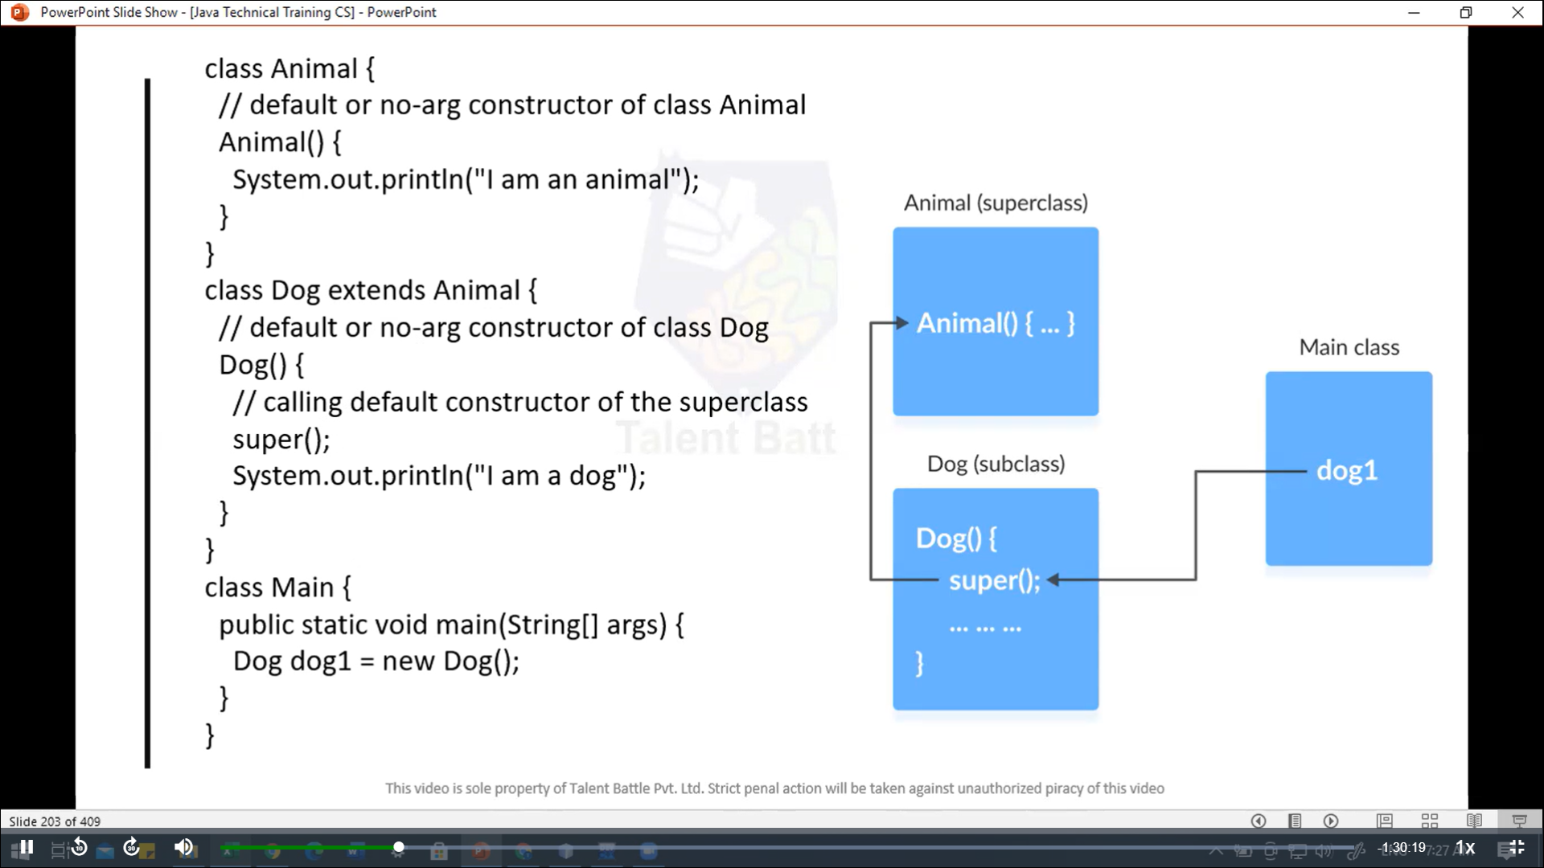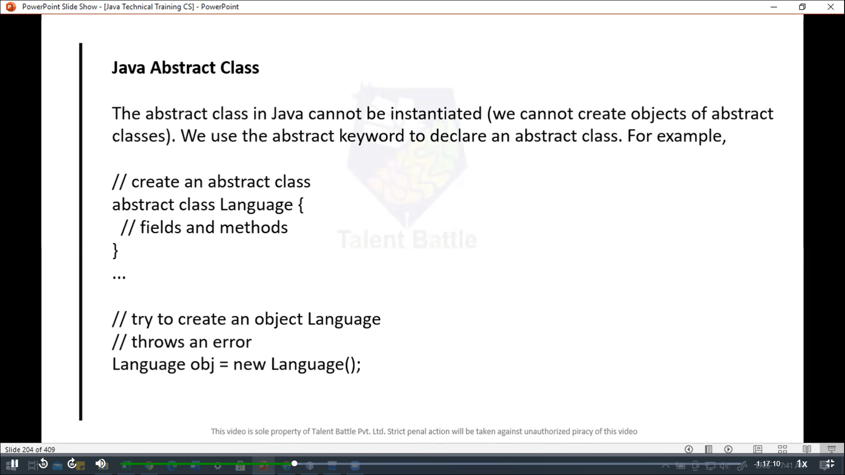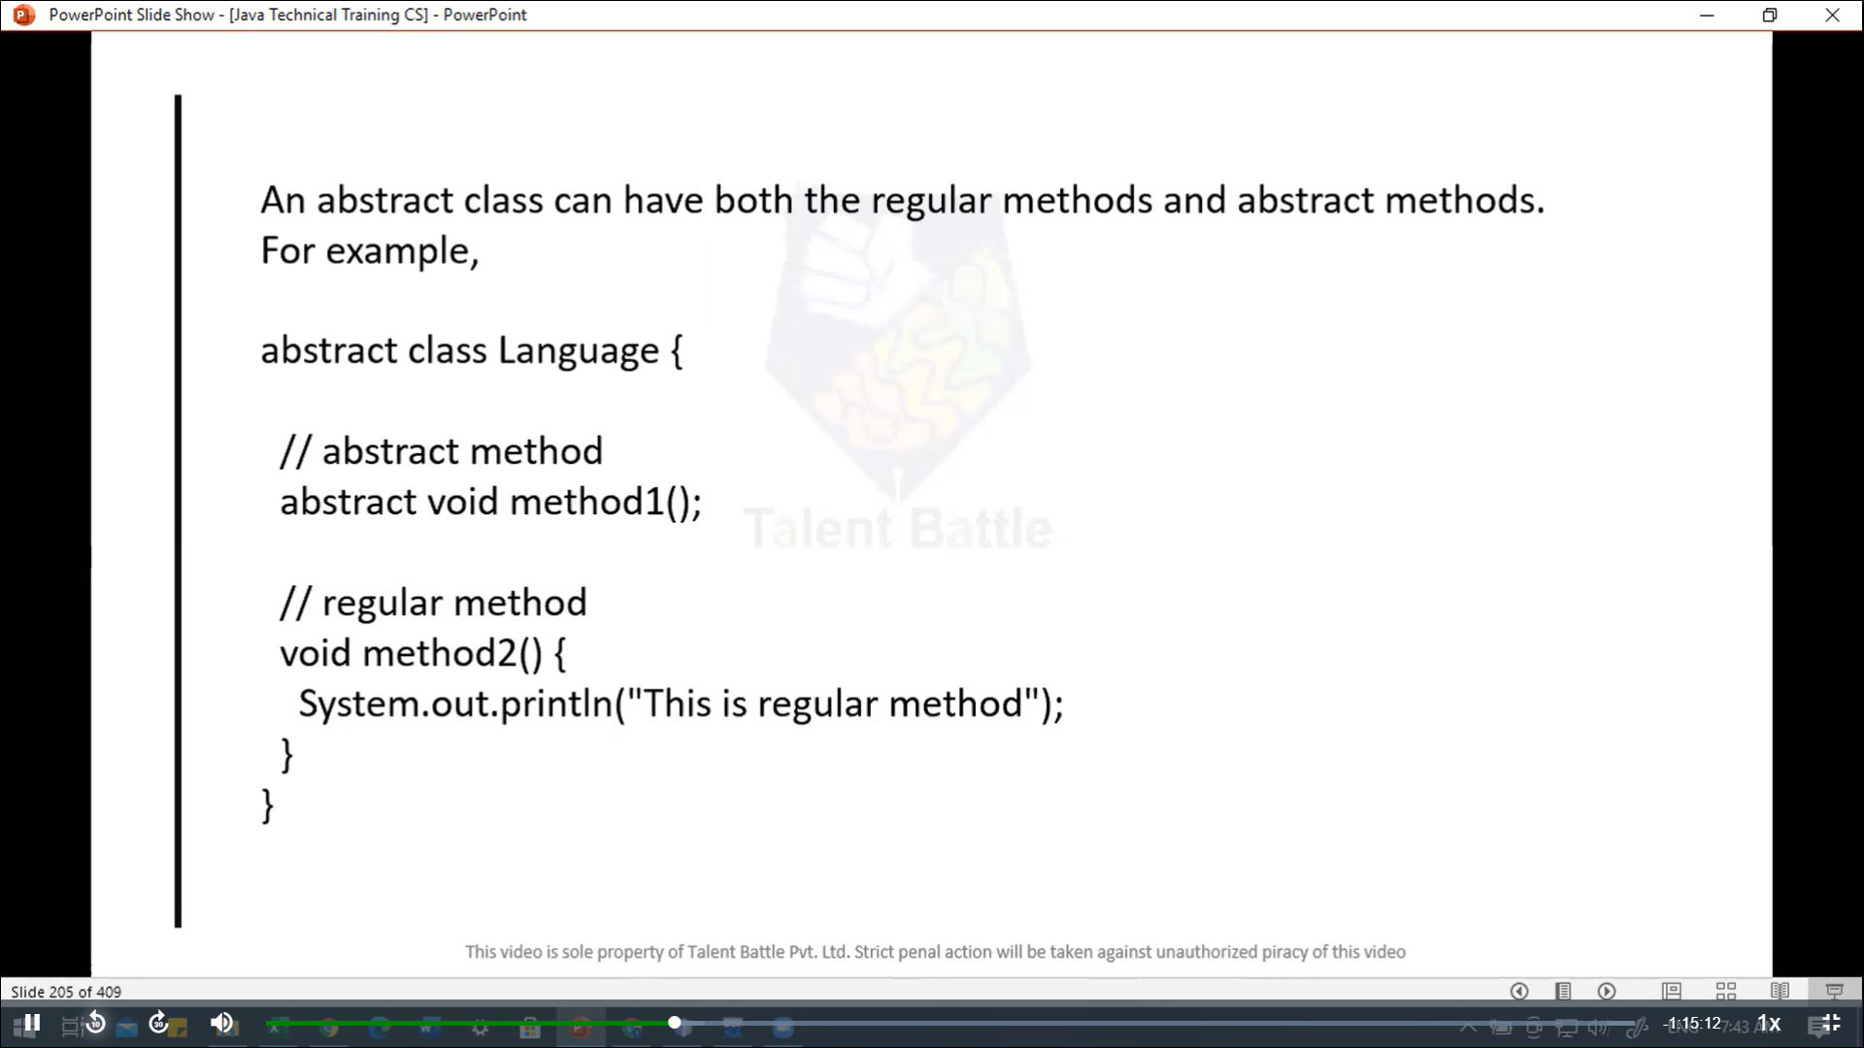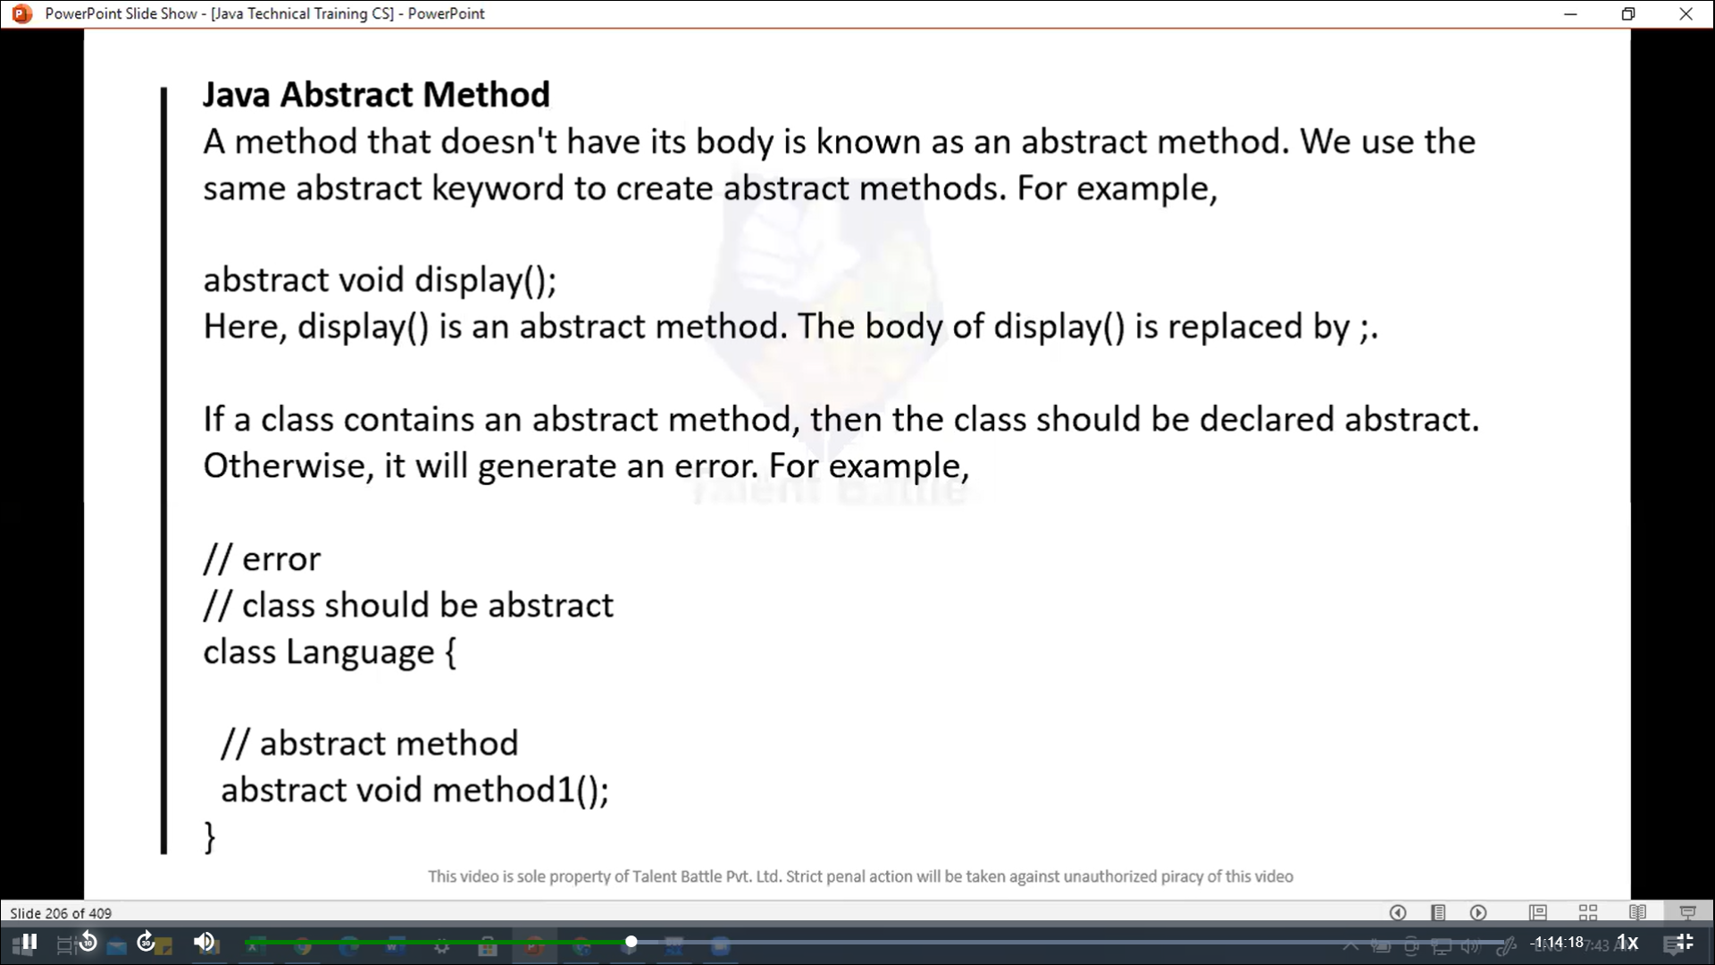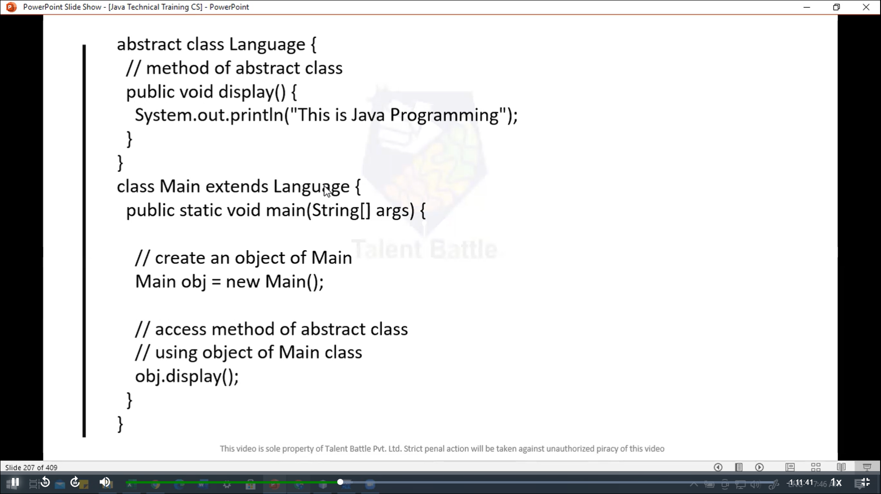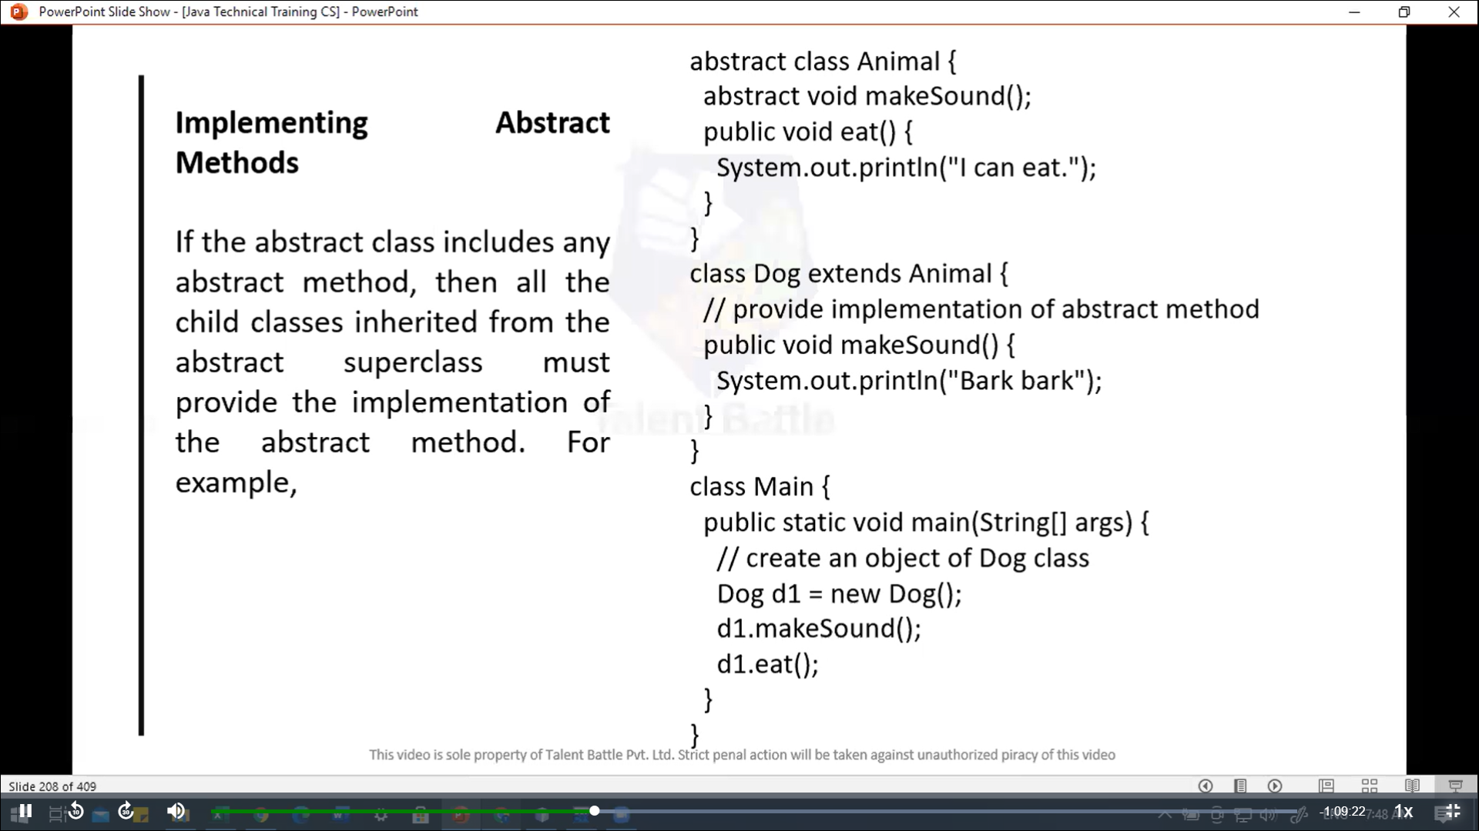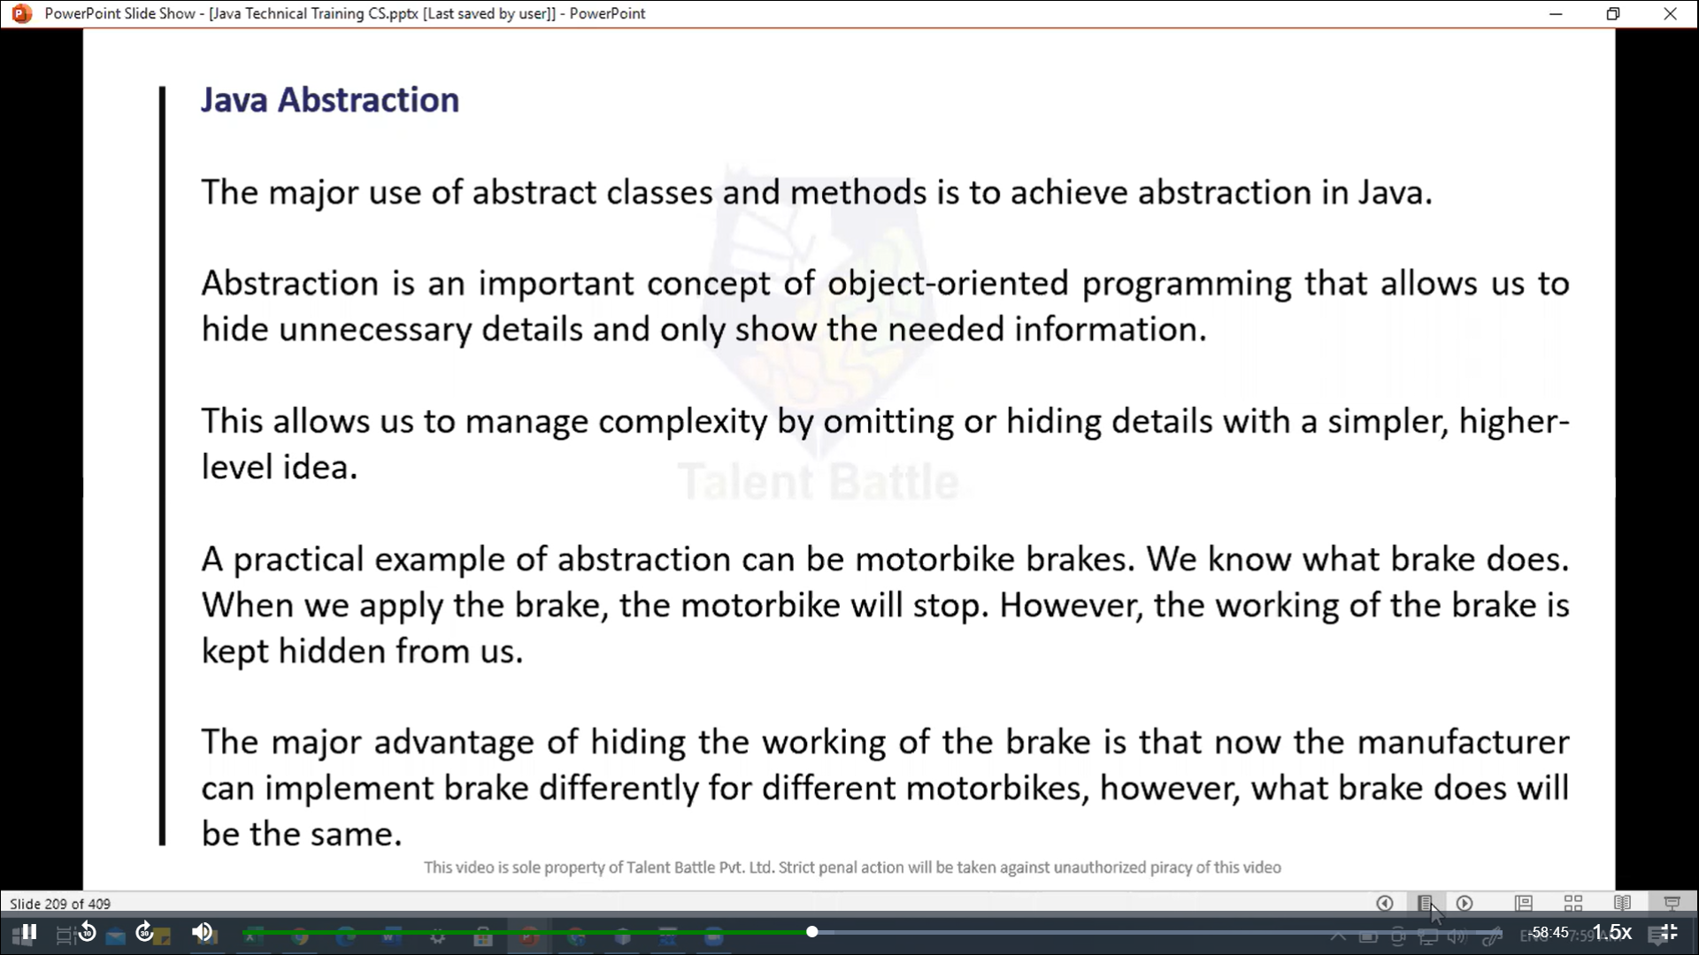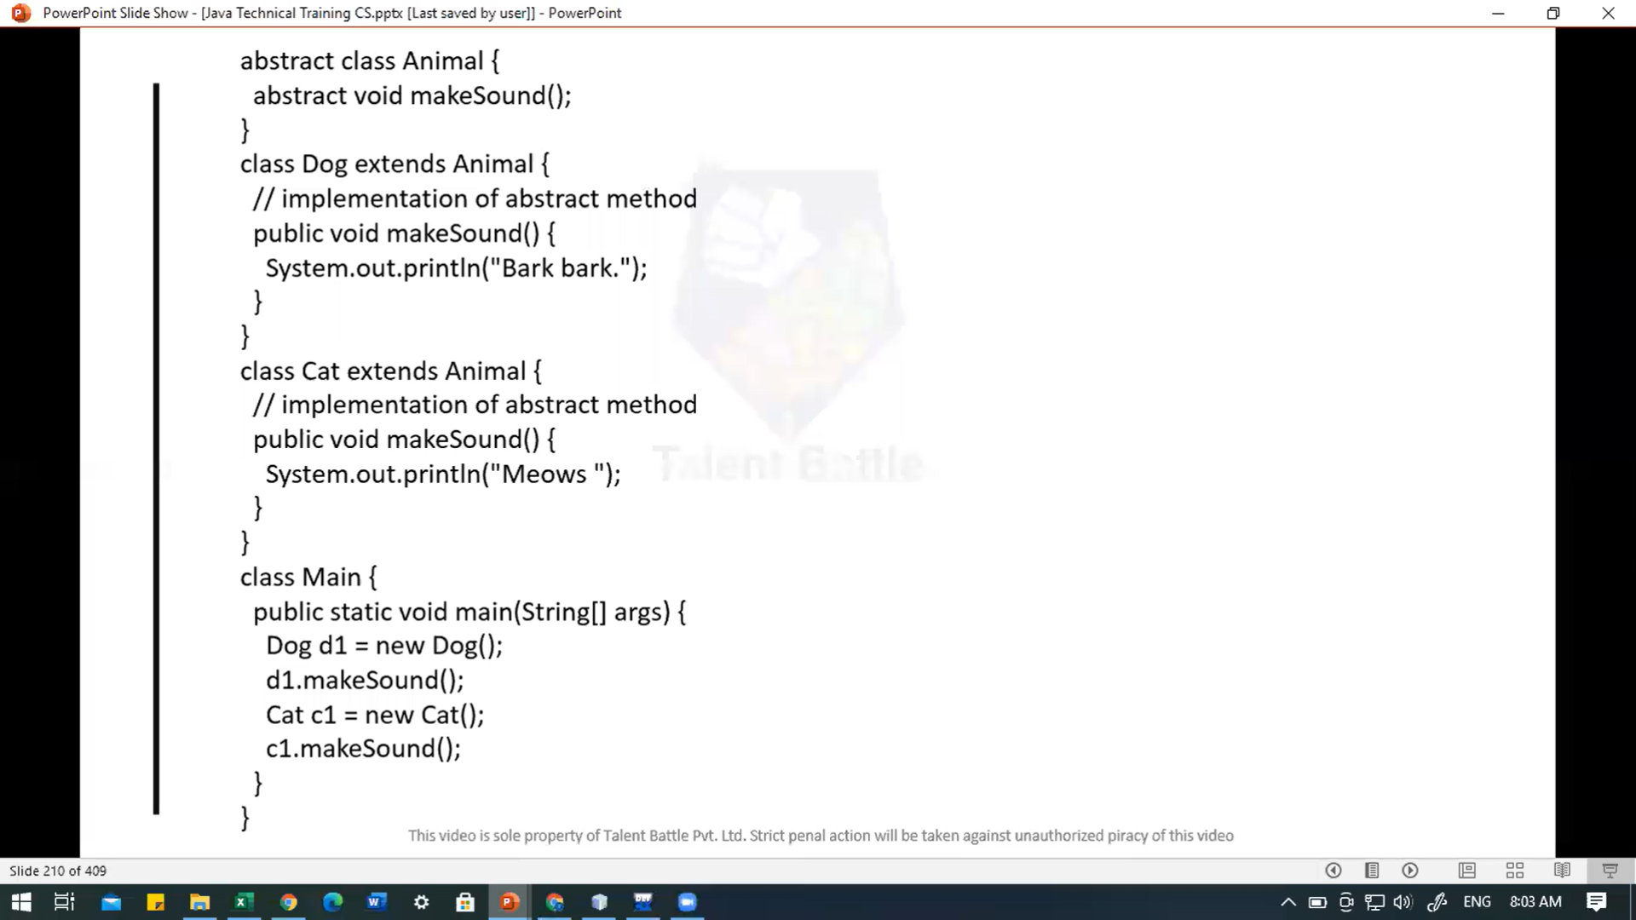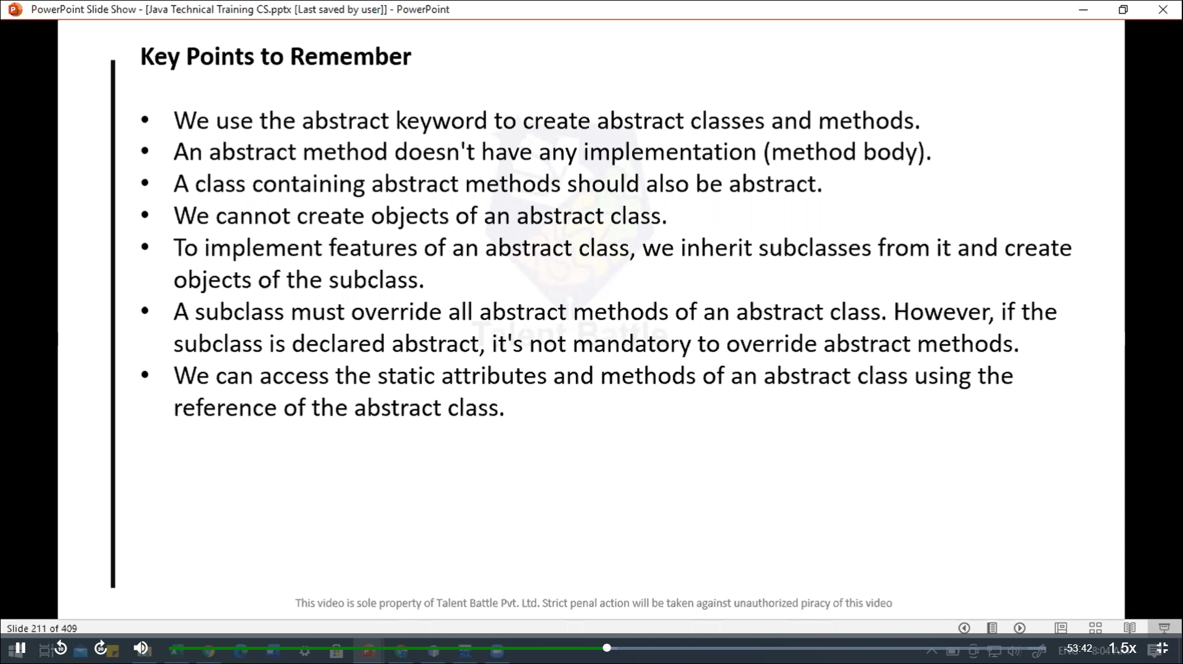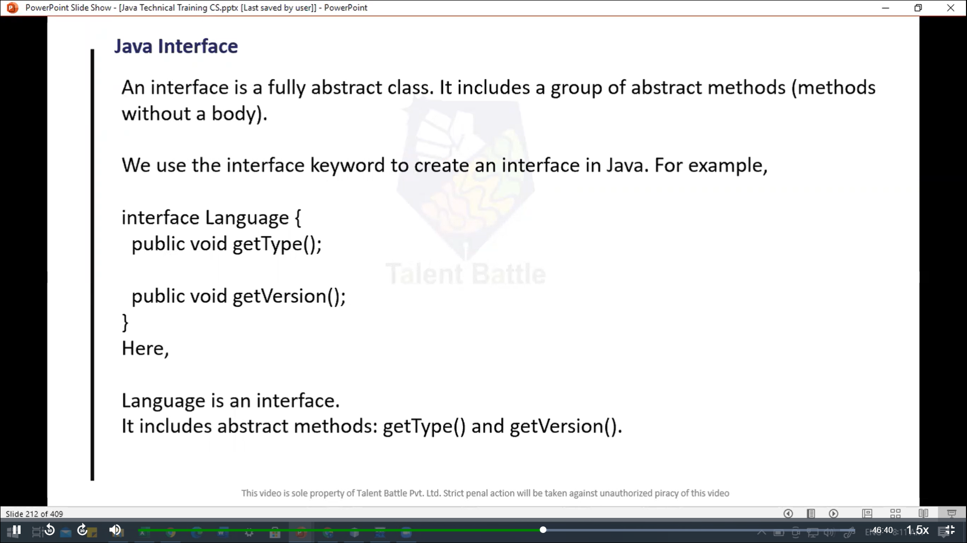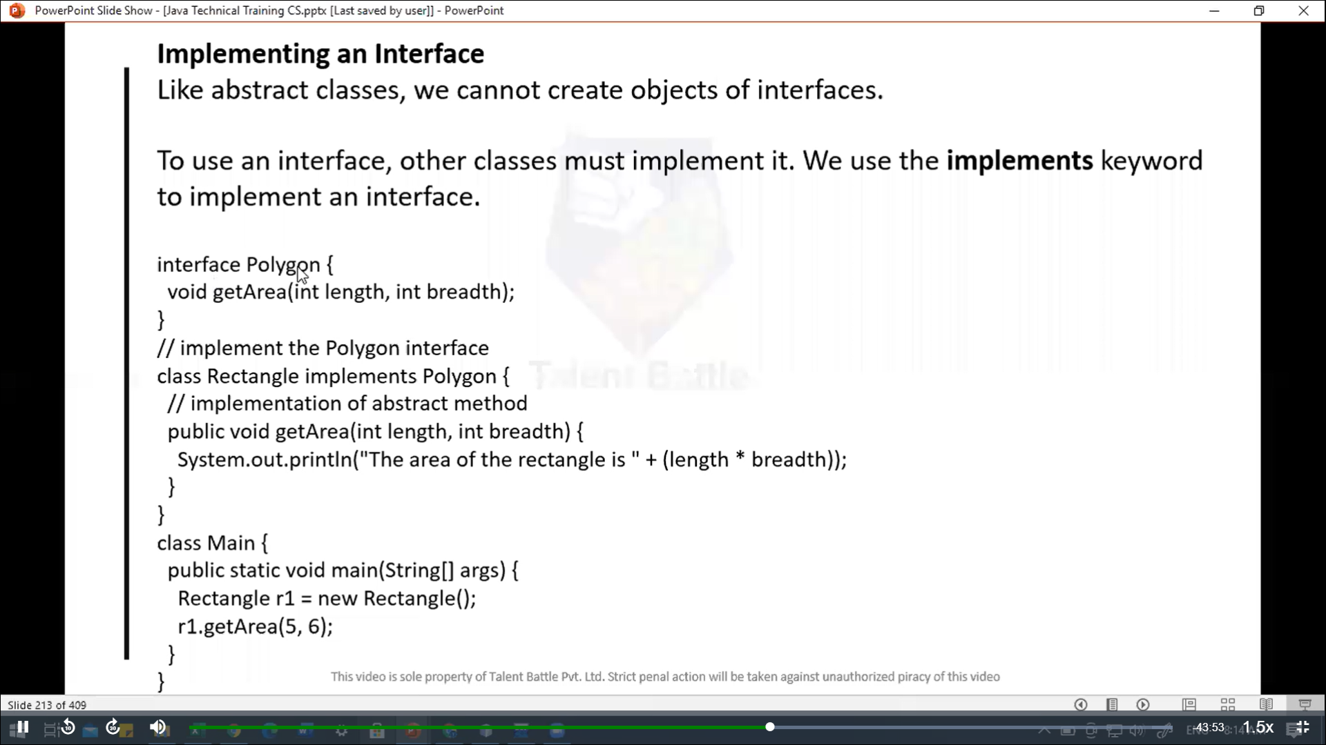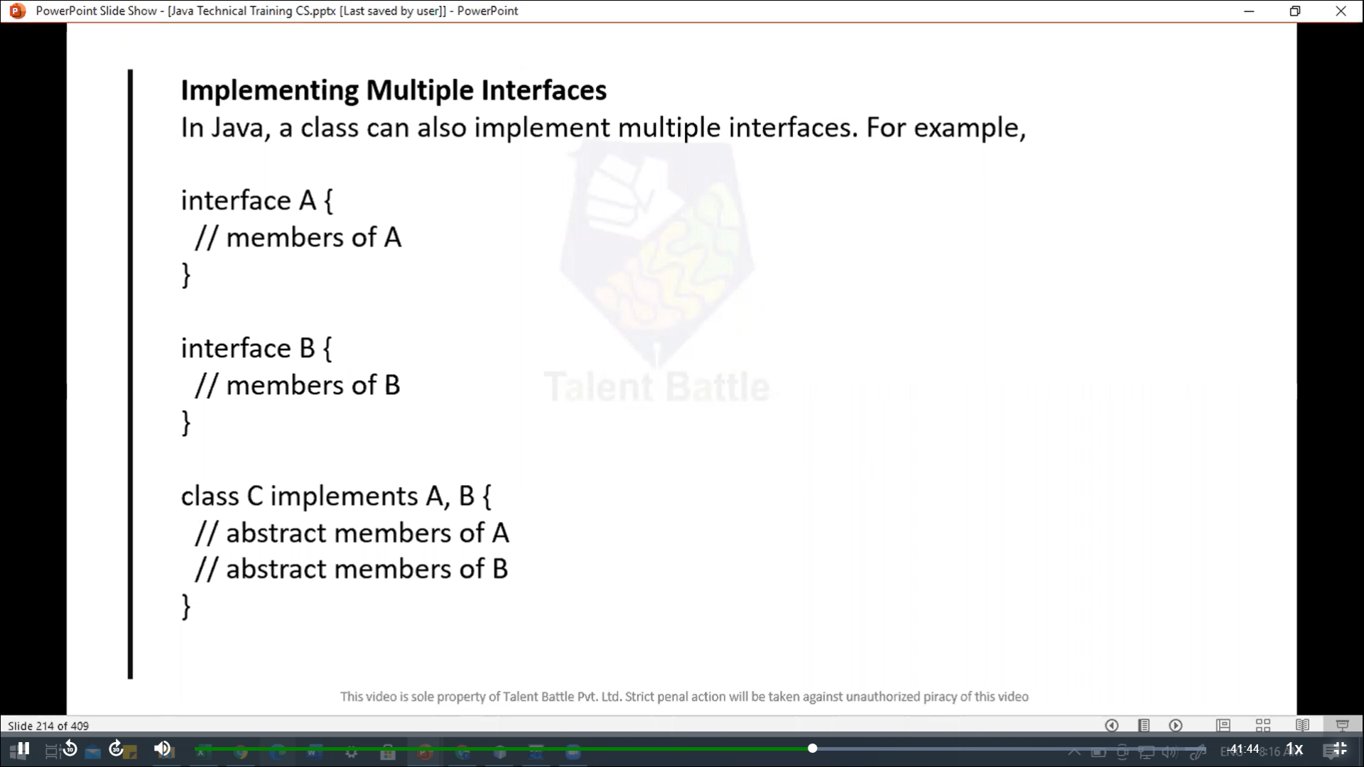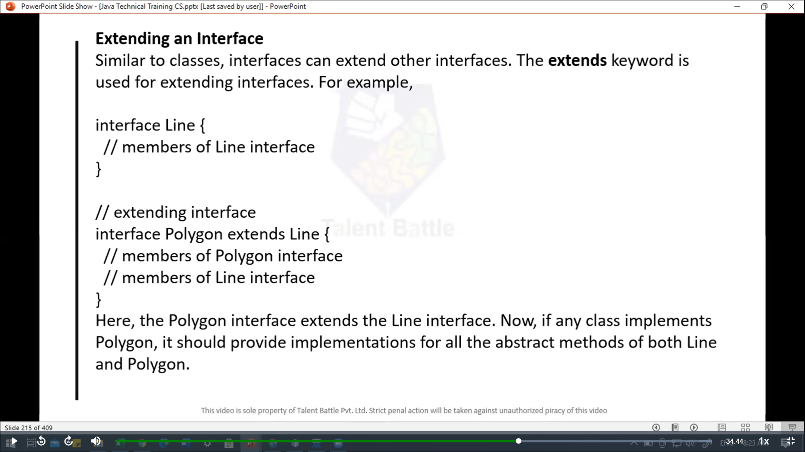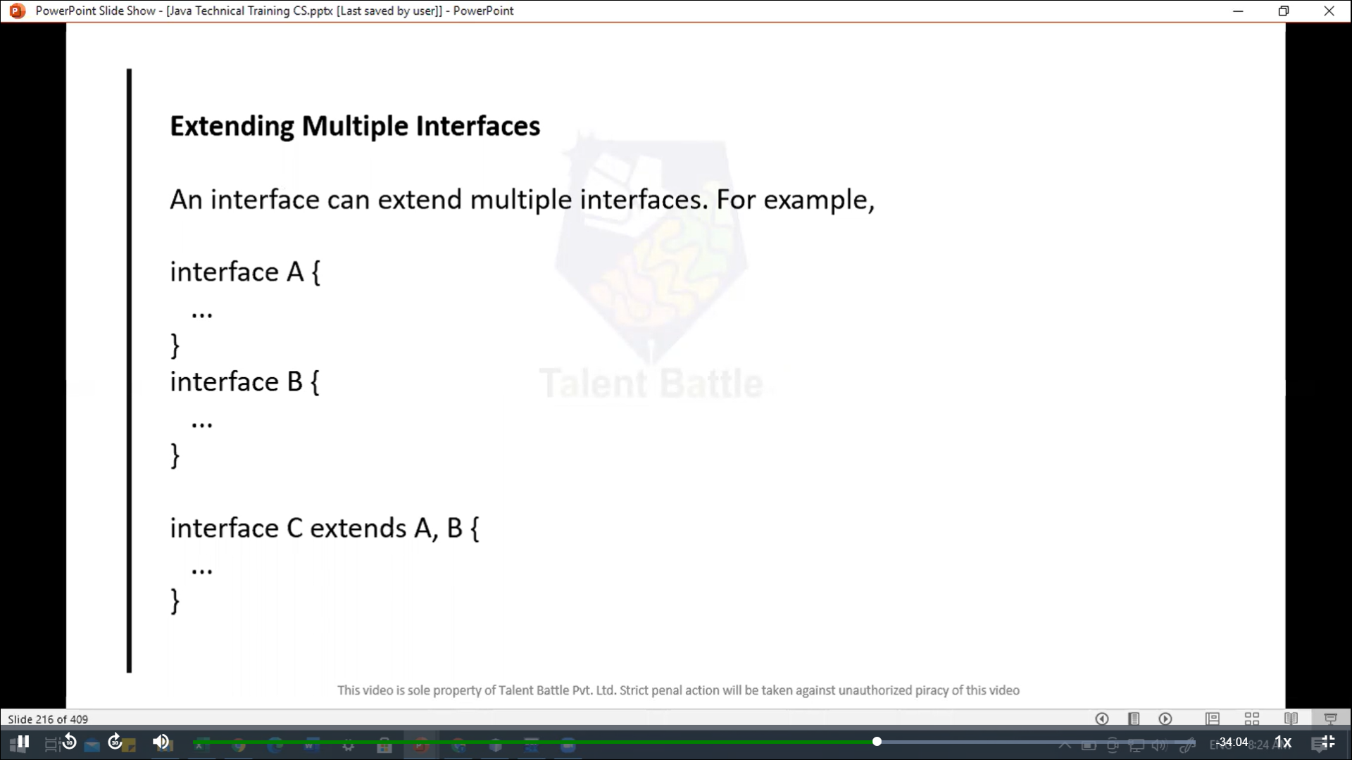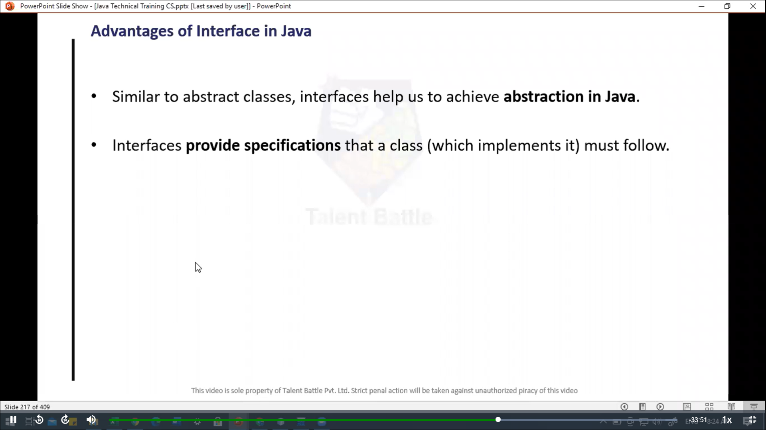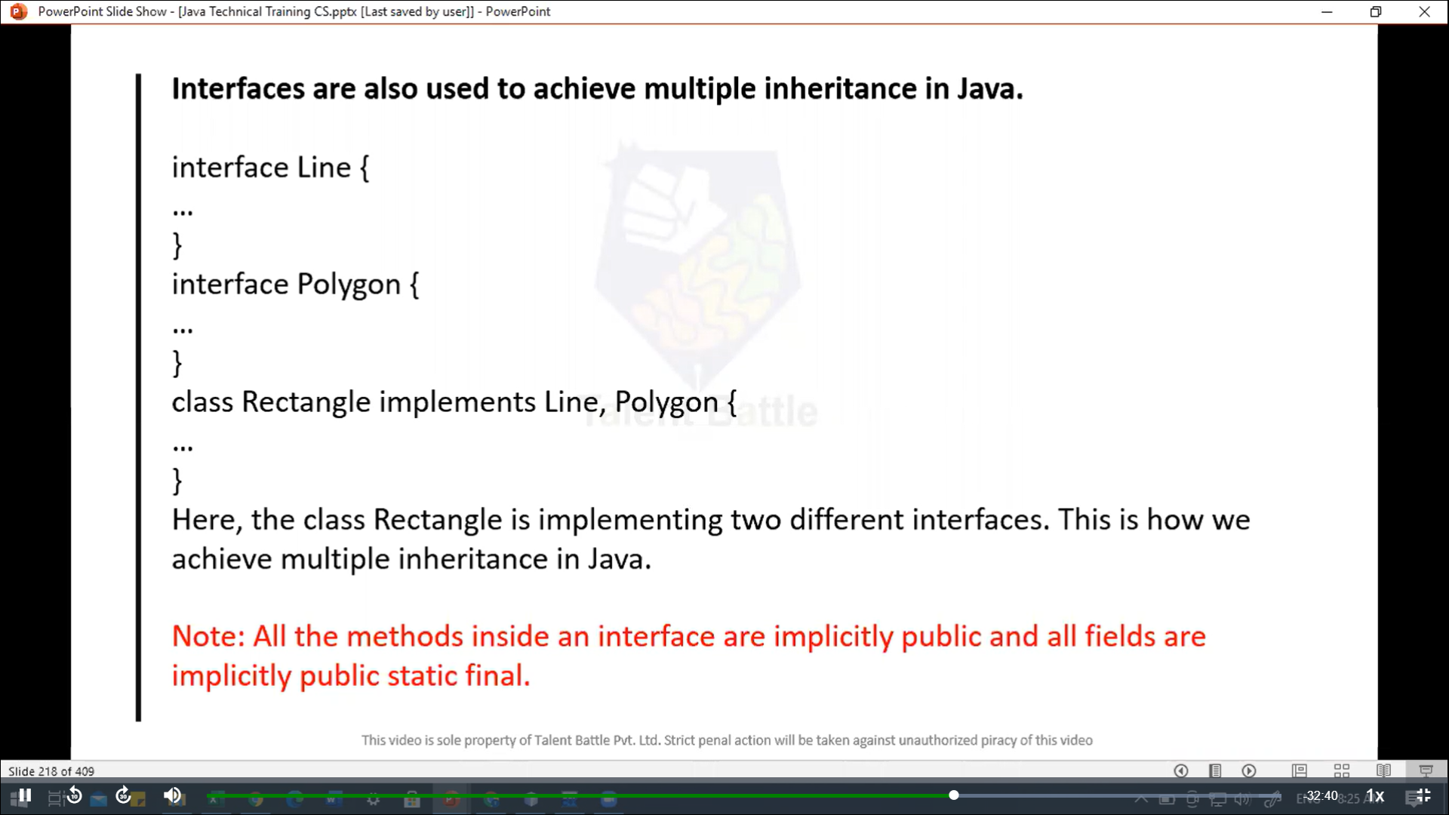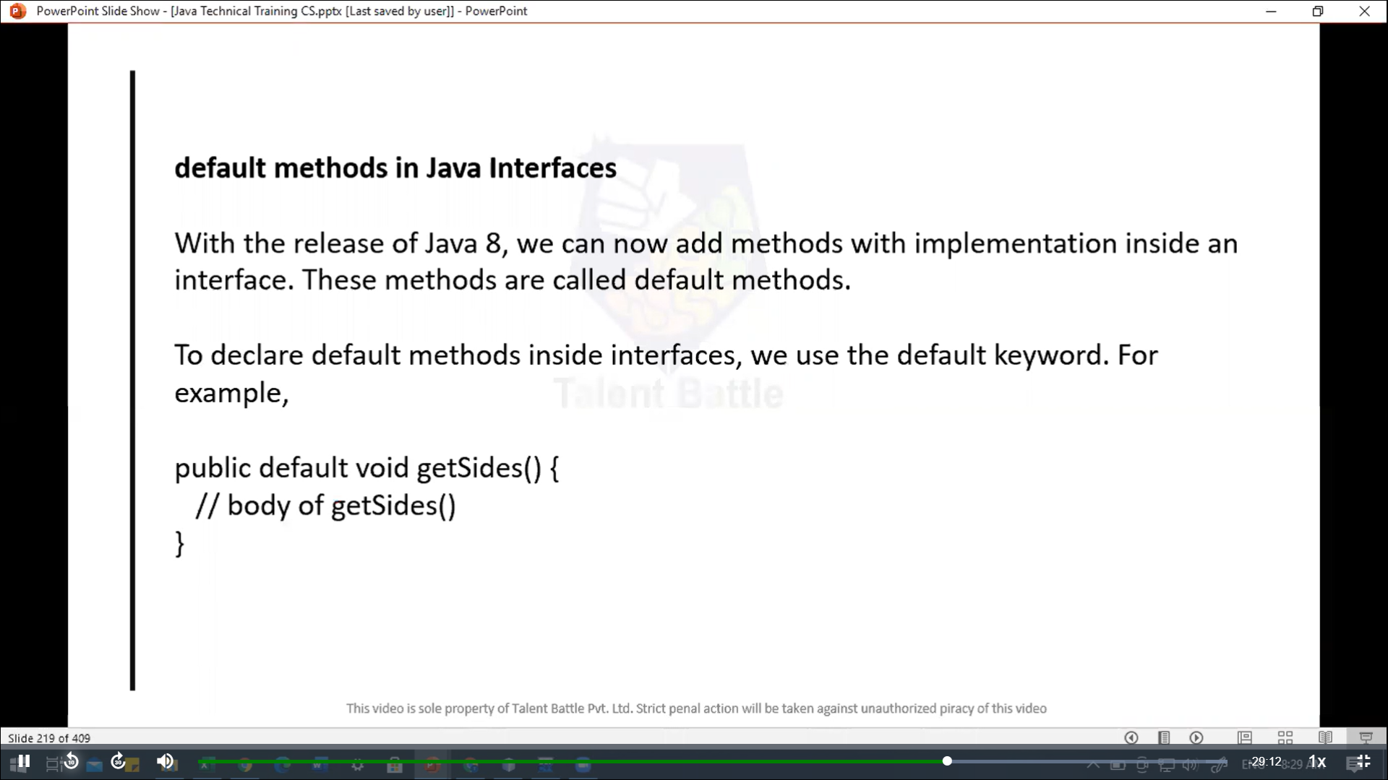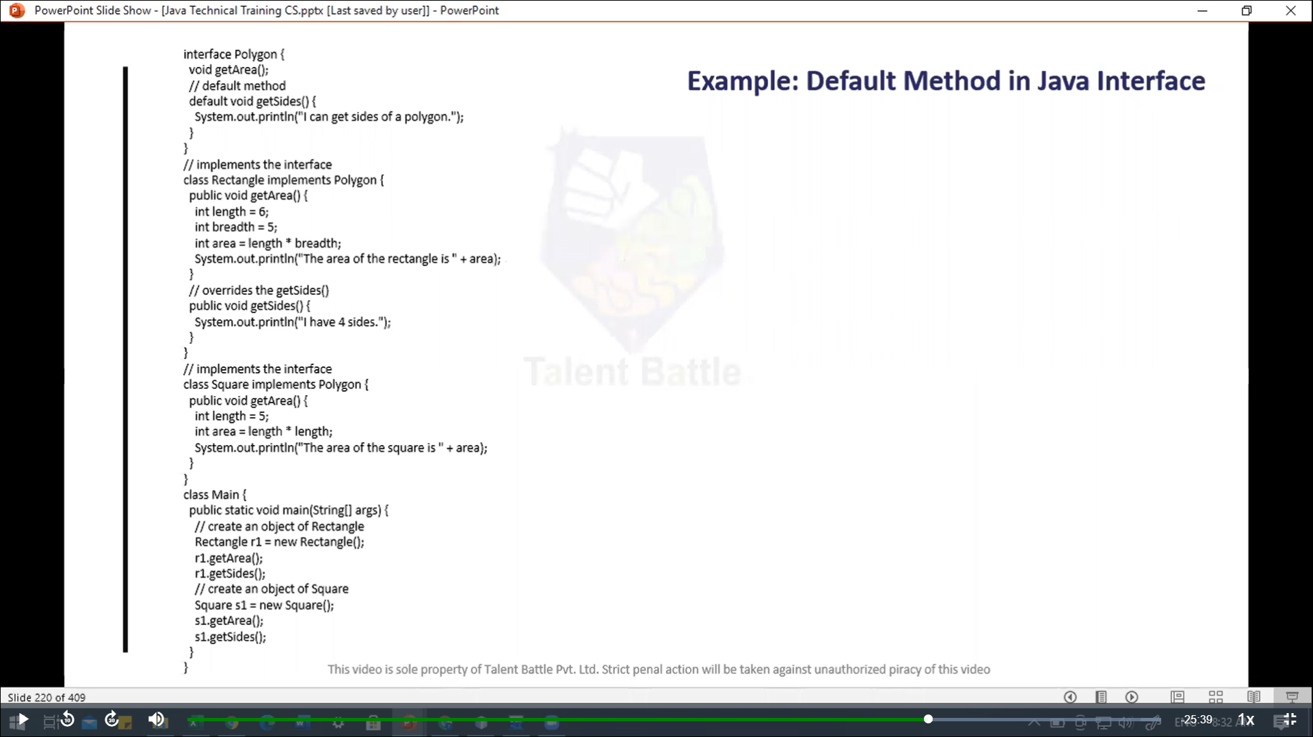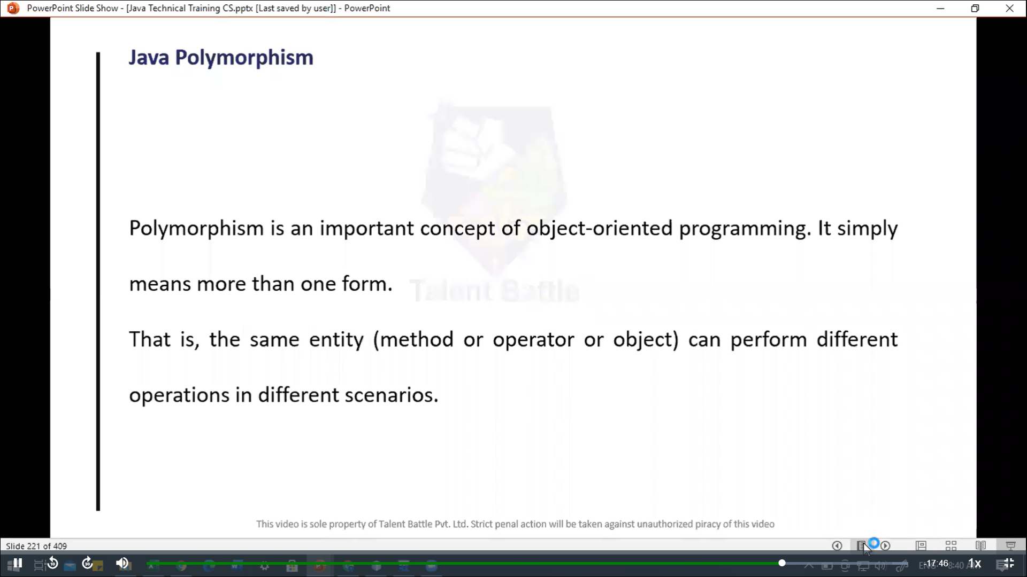

package Day7;

// Inheritance, Abstraction, Interface, Polymorphism

/*

// Method Overriding in java inheritance

class Animal{

    public void eat(){

        System.out.println("I can eat");

    }

}

class Dog extends Animal{

    // overriding the eat() method

    @Override

    public void eat(){

        System.out.println("I eat dog food");

    }

    // new method in subclass

    public void bark(){

        System.out.println("I can bark");

    }

}

class Main {

    public static void main(String[] args) {

        // create an object of the subclass

        Dog labrador = new Dog();

        // call the eat() method

        labrador.eat();

        labrador.bark();

    }

}

// ++++++++++++++++ output ++++++++++++++++++++

// @Dheeraj2002kumar ➜ /workspaces/Foundation-Language (main) $ cd Java/

// @Dheeraj2002kumar ➜ /workspaces/Foundation-Language/Java (main) $ javac Day7/Main.java

// @Dheeraj2002kumar ➜ /workspaces/Foundation-Language/Java (main) $ java Day7.Main

// I eat dog food

// I can bark

 */

// --------------------------------------------------------------

// super class

/*

class Animal{

    public void eat(){

        System.out.println("I can eat");

    }

}

class Dog extends Animal{

    // overriding the eat() method

    @Override

    public void eat(){

        // call mrthod of superclass

        super.eat();

        System.out.println("I eat dog food..");

    }

    // new method in subclass

    public void bark(){

        System.out.println("I can bark...");

    }

}

public class Main {

    public static void  main(String[] args){

        Dog labrador = new Dog();

        // call the eat() method

        labrador.eat();

        labrador.bark();

    }

}

// +++++++++++++++++++++++ output ++++++++++++++++++++++++

// @Dheeraj2002kumar ➜ /workspaces/Foundation-Language/Java (main) $ javac Day7/Main.java

// @Dheeraj2002kumar ➜ /workspaces/Foundation-Language/Java (main) $ java Day7.Main

// I can eat

// I eat dog food..

// I can bark...

*/

 //-----------------------------------------------------

 // protected members in Inheritance

/*

class Animal{

    protected String name;

    protected void display(){

        System.out.println("I am an animal.");

    }

}

class Dog extends Animal{

    public void getInfo(){

        System.out.println("My name is " + name);

    }

}

 public class Main {

    public static void main(String[] args) {

        Dog labrador = new Dog();

        labrador.name = "Pinky";

        labrador.display();

        labrador.getInfo();

    }

 }

 //+++++++++++++++ output +++++++++++++++++

//  @Dheeraj2002kumar ➜ /workspaces/Foundation-Language/Java (main) $ javac Day7/Main.java

// @Dheeraj2002kumar ➜ /workspaces/Foundation-Language/Java (main) $ java Day7.Main

// I am an animal.

// My name is Pinky

 */

 // ---------------------------------------

/*

 // super class constructor

 class Animal{

    // default ro no-argument constructor of class Animal

    Animal(){

        System.out.println("I am an animal");

    }

 }

 class Dog extends Animal{

    // default or no-argument constructor of class Dog

    Dog(){

        // calling default constructor of the superclass

        super();

        System.out.println("I am a dog...");

    }

 }

 public class Main{

    public static void main(String[] args) {

        Dog dog1 = new Dog();

    }

 }

 // ++++++++++++++++++++++++ output ++++++++++++++++++++++++++++

//  @Dheeraj2002kumar ➜ /workspaces/Foundation-Language/Java (main) $ javac Day7/Main.java

// @Dheeraj2002kumar ➜ /workspaces/Foundation-Language/Java (main) $ java  Day7.Main

// I am an animal

// I am a dog...

 */

 //-----------------------------------------------------

/*

 // Abstract class

 abstract class Language{

    // method of abstract class

    public void display(){

        System.out.println("This is Java Programming...");

    }

 }

 class Main extends Language {

    public static void main(String[] args) {

        // create an object of Main

        Main obj = new  Main();

        // access method of abstract class

        // using object of Main class

        obj.display();

    }

 }

 // ++++++++++++++++++++++ output +++++++++++++++++++++++++++

//  @Dheeraj2002kumar ➜ /workspaces/Foundation-Language/Java (main) $ javac Day7/Main.java

// @Dheeraj2002kumar ➜ /workspaces/Foundation-Language/Java (main) $ java  Day7.Main

// This is Java Programming...

 */

//---------------------------------------------------------------------

/*

// Implementing Abstract Methods:-

// If the abstract class include any abstract method, then all the child classes inherited from the abstract superclass must provide the implementation of the abstrac method.

abstract class Animal{

    abstract void makeSound();

    public void eat(){

        System.out.println("I can eat..");

    }

}

class Dog extends Animal{

    // provide implementation of abstract method

    public void makeSound(){

        System.out.println("Bark bark...");

    }

}

class Main{

    public static void main(String[] args) {

        // create an object of Dog Class

        Dog d1 = new Dog();

        d1.makeSound();

        d1.eat();

    }

}

// ++++++++++++++++++ output +++++++++++++++++++++++++

// @Dheeraj2002kumar ➜ /workspaces/Foundation-Language/Java (main) $ javac Day7/Main.java

// @Dheeraj2002kumar ➜ /workspaces/Foundation-Language/Java (main) $ java  Day7.Main

// Bark bark...

// I can eat..

 */

// -------------------------------------------------------

/*

// java Abstraction

abstract class Animal{

    abstract void makeSound();

}

class Dog extends Animal{

    // implementation of abstract method

    public void makeSound(){

        System.out.println("Bark bark....");

    }

}

class Cat extends Animal{

    // implementation of abstract method

    public void makeSound(){

        System.out.println("Meows...");

    }

}

class Main{

    public static void main(String[] args){

        Dog d1 = new Dog();

        d1.makeSound();

        Cat c1 = new Cat();

        c1.makeSound();

    }

}

// ++++++++++++++++++++ output +++++++++++++++++++++

// @Dheeraj2002kumar ➜ /workspaces/Foundation-Language/Java (main) $ java  Day7.Main

// Bark bark....

// Meows...

 */

 //------------------------------------------------------

/*

 // Implementing an interface:-

 // Like abstract classes, we cannot create objects of interfaces.

 // To use an interface, other classes must implement it. We use the implements keyword to implement an interface.

 interface Polygon{

    void getArea(int length, int breadth);

 }

 // implement the  Polygon interface

 class Rectangle implements Polygon{

    // implementation of abstract method

    public void getArea(int length, int breadth){

        System.out.println("The area of the rectangle is " + (length * breadth));

    }

 }

 class Main{

    public static void main(String[] args) {

        Rectangle r1 = new Rectangle();

        r1.getArea(5, 6);

    }

 }

 // ++++++++++++++++++++++++  output ++++++++++++++++

//  @Dheeraj2002kumar ➜ /workspaces/Foundation-Language/Java (main) $ javac Day7/Main.java

// @Dheeraj2002kumar ➜ /workspaces/Foundation-Language/Java (main) $ java  Day7.Main

// The area of the rectangle is 30

 */

 // --------------------------------------------------------

 /*

// Example: Default Method in java Interface

interface Polygon{

    void getArea();

    // default method

    default void getSides(){

        System.out.println("I can get sides of a polygon...");

    }

}

// implements the interface

class Rectangle implements Polygon{

    public void getArea(){

        int length = 6;

        int breadth = 5;

        int area = length * breadth;

        System.out.println("The area of the rectangle is " + area);

    }

    // overrides the getSides()

    public void getSides(){

        System.out.println("I have 4 sides.");

    }

}

// implements the interface

class Square implements Polygon{

    public void getArea(){

        int length = 5;

        int area = length * length;

        System.out.println("The area of the square is " + area);

    }

}

class Main{

    public static void main(String[] args){

        // create an object of Rectangle

        Rectangle r1 = new Rectangle();

        r1.getArea();

        r1.getSides();

        // create an object of Square

        Square s1 = new Square();

        s1.getArea();

        s1.getSides();

    }

}

// ++++++++++++++++++++++ output +++++++++++++++++++++++++

// @Dheeraj2002kumar ➜ /workspaces/Foundation-Language/Java (main) $ javac Day7/Main.java

// @Dheeraj2002kumar ➜ /workspaces/Foundation-Language/Java (main) $

// @Dheeraj2002kumar ➜ /workspaces/Foundation-Language/Java (main) $

// @Dheeraj2002kumar ➜ /workspaces/Foundation-Language/Java (main) $ java  Day7.Main

// The area of the rectangle is 30

// I have 4 sides.

// The area of the square is 25

// I can get sides of a polygon...

 */

// -------------------------------------------------------

// Java polymorphism

class Polygon{

    // method to render a shape

    public void render(){

        System.out.println("Rendering Polygon...");

    }

}

class Square extends Polygon{

    // renders Square

    public void render(){

        System.out.println("Rendering Square...");

    }

}

class Circle extends Polygon{

    // renders circle

    public void render(){

        System.out.println("Rendering Circle...");

    }

}

class Main{

    public static void main(String[] args){

        // create an object of Square

        Square s1 = new Square();

        s1.render();

        // create an object of Circle

        Circle c1 = new Circle();

        c1.render();

    }

}

// +++++++++++++++++ output ++++++++++++++++++++++++++

// @Dheeraj2002kumar ➜ /workspaces/Foundation-Language/Java (main) $ javac Day7/Main.java

// @Dheeraj2002kumar ➜ /workspaces/Foundation-Language/Java (main) $ java Day7.Main

// Rendering Square...

// Rendering Circle...